Modeling Patient-Initiated Timing to Minimize Waits at Vancouver Island Hospital Emergency Departments
Using a Queueing-Network Approach

Taylor Dew-Jones, Jay Robertson
November 10, 2025
CSC 446: Simulations in Operations Research
University of Victoria, Victoria, BC, CA

“Modeling Patient-Initiated Timing to Minimize Waits at Vancouver Island Hospital Emergency Departments Using a Queueing-Network Approach”

Dew-Jones, T., Robertson J.

Table of Contents
“Modeling Patient-Initiated Timing to Minimize Waits at Vancouver Island Hospital Emergency Departments Using a Queueing-Network Approach” 2
Problem Description 3
Queueing Model 4
Simulation Goals and Parameters 7
Methodology 8
Simulation System Setup 8
Statistics Collection 9
Results & Analysis 10
Theoretical Data 10
Simulated Data 14
Conclusion 18
Results and Analysis Summary: Simulation 18
Results and Analysis Summary: Theoretical 18
Recommendations 19
References 20
Table of Figures 20
Table of Tables 20

Problem Description
Hospital emergency departments (ED) on Vancouver Island have been facing increasing long wait times over the last few years, with observations of patients consistently needing half a day or more to get through the system. Recent reports state that the two largest hospital EDs on Vancouver have average wait times of close to six and a half hours, with 50% of patients waiting longer (Chan, 2025). Warnings of a larger issue existing within the health care system that cannot be affected by most everyday users began as far back as 2004 (Anon, 2004). Until broader system changes can take place, patients need to consider other methods for reducing their wait time, such as by strategically entering the ED at a certain time of the day. While an online service was launched recently for dynamic wait time tracking, allowing potential patients to observe the current waits, it does not provide the information to allow for pre-planning the best time to enter the ED for minimized wait times (Zeidler, 2025). This simulation is intended to track back the wait times for patients to find out on an hourly basis what time of the day leads to the lowest wait for them. Many of the chosen simulation parameters and features were based on an author’s time working in the ED at a Vancouver Island Hospital.

Queueing Model
For this simulation, a three tiered queueing system is used: patients first arrive at the Triage Queue, then move to one of three Testing Queues for bloodwork, electrocardiogram (ECG), and X-ray, and and finally move to see a doctor at the Diagnosis Queue where the patient is either discharged immediately or held for observation before discharge. All queues are treated as FIFO-Priority queues: patients with a level 1 priority are moved to the front of each queue they are placed in, but patients with levels 2, 3, or 4 are treated as first come first served. Patients are assigned a priority level using the memoryless probability as they entered at Triage, with probabilities of 3% for level, 42% for level 2, 45% for level 3, and 10% for level 4.
The incoming patient arrivals are countably infinite and generated using a Poisson arrival process, with the simulation running for a length based on an inputted number of days to be simulated. One service member is able to aide one patient from an arrival or queue at a time. All queues are staffed by a minimum of one server, but most queues do not have consistent staffing levels throughout the day; at different set times of day, a shift change will occur where the number of staff members servicing the arrivals will increase, decrease, or stay the same a set amount dependent on the time. While the queues are limited in their capacity only by the computer capacity, an endless or infinite number of patients should never occur unless the staffing levels are too low or patient arrivals are too high, and thus not accurately mimicking the real world scenario found at Vancouver Island EDs. The simulation does not account for the real-world phenomenom of patients who arrive and begin the process but who leave at any point before the natural discharge, known as left without being seen, and thus results must be subject to greater variance.
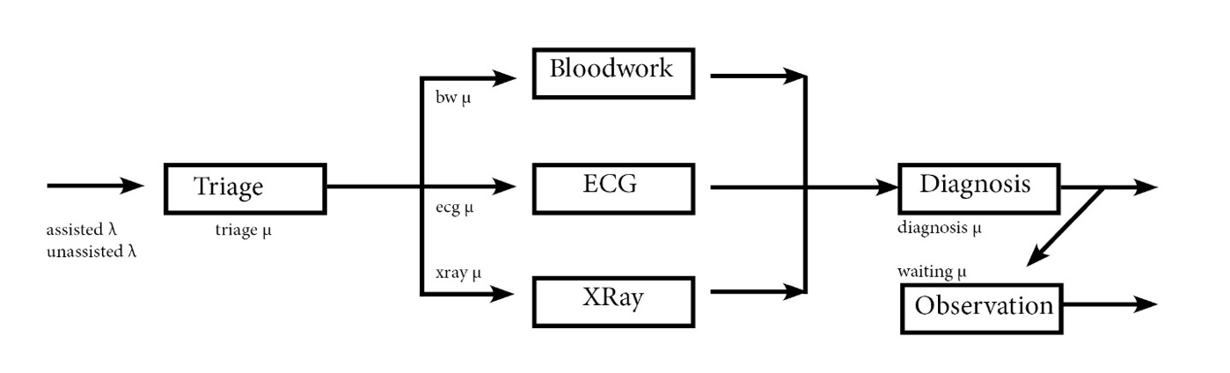
Figure 1. Shows the simulation flow for patients from triage through to discharge.
Service member type | Average µ per service member (hourly)
Triage nurse | 12 patients
Bloodwork nurse | 16 patients
ECG nurse | 10 patients
Xray nurse | 6 patients
Doctor | 5 patients
Table 1. Average service time per nurse at each queue, tracked hourly.
Patients of two types are dealt with in the simulation: patients who arrive unassisted, meaning they enter the ED of their own volition and on their own; patients who arrive assisted, meaning they are brought in via ambulance with paramedics. Patients who are brought in against their desires, by police or social workers, were not considered in this simulation. They are a small number compared to the other two methods of patient entry, and these patients are often treated within the Psychiatric Emergency Services (PES), a separate area of the ED and not part of the main patient flow. The registration desk is also not included as a separate queue, but rather it is assumed that registration will not alter a patient’s time between being triaged and getting to their testing queue. These two types of patients arrived with different arrival rates at different times of day (see Table 2). Triage queueing model is M/M/c, where c is defined by the staffing levels throughout a 24-hour period.
Arrival rates to triage (interarrival (min)) | 00:00  to  03:00 | 03:01  to  07:00 | 07:01  to  19:00 | 19:01  to  23:59
Unassisted | 7.5 | 90 | 6.5 | 5.5
Assisted | 11.25 | 45 | 15 | 22.5
Table 2. Interarrival rates of patients to triage, tracked in time intervals.
Triage staffing | 00:00  to  03:00 | 03:01  to  07:00 | 07:01  to  19:00 | 19:00  to  23:59
Number of nurses | 3 | 1 | 2 | 3
Table 3. Staffing levels at triage, tracked in time intervals.
Once through the Triage Queue, patients are randomly assigned by memoryless probability to a testing queue, so there is no connection between any patients as to what testing happens for them. It was assumed patients will not need to go through multiple Testing Queues, so patients are then sent through one of three Test Queues: bloodwork, ECG, or X-ray. It was also assumed that patients with the highest triage level, level 1, never need to get an X-ray in the ED because their condition is such that there is almost always something more life threatening than an X-ray can help with at the time when that patient would be in the ED. In real hospitals, patients who get an ECG do often get bloodwork as well, but that was ignored for the purposes of this simulation. All the Testing Queues can be modelled the same way: M/M/c, where c is defined by the staffing levels throughout a 24-hour period, and the arrival rates stay as Poisson because just the one triage queue feeds into the testing queues via splitting.

Tests staffing  Number of nurses | 00:00  to  03:00 | 03:01  to  07:00 | 07:01  to  19:00 | 19:00  to  23:59
Bloodwork | 3 | 3 | 3 | 3
ECG | 1 | 1 | 1 | 1
XRay | 1 | 1 | 1 | 1
Table 4. Staffing levels at the testing, tracked in time intervals.
Following this, patients were moved to the Diagnosis Queue where they wait for a doctor to see them. It was assumed that 80% of patients would be discharged right away after seeing a doctor and being given any instructions or follow-up care. 20% of patients in the ED are given beds or stretchers where they could stay to be observed for some time. Patients were randomly selected based on memoryless probability to stay in the Waiting Queue. The amount of time they spent waiting before discharge was also randomly assigned based on memoryless probability, from anywhere between three and twelve hours.
For the purposes of this simulation, patients who have left the ED are assumed to be discharged from the hospital, which ignores cases of patients who are held in the ED to be admitted into the main hospital. This means that the wait time for a patient to receive a bed, in this case simulated with the waiting queue, is not considered. With limited number of beds in the hospital, many patients wait to be admitted to the main hospital in the beds of the ED, limiting the capacity for short term emergency patients to access those beds; this was not considered because of the larger integration that would be required. The diagnosis queue can be described as M/M/c, where c is defined by the staffing levels throughout a 24-hour period, and the arrival rate stays as Poisson because although three testing queues feed into this one diagnosis queue, they all inherit the Poisson arrival from the triage queue and are Poisson arrivals themselves.
Doctor staffing for Diagnosis | 00:00  to  05:00 | 05:01  to  06:00 | 06:01  to  07:00 | 07:01  to  16:00 | 16:00  to  17:00 | 17:01  to  23:59
Number of Doctors | 1 | 2 | 3 | 4 | 3 | 2
Table 5. Staffing levels at diagnosis, tracked in time intervals.
The additional assumption made throughout all the queues is the style of priority-FIFO queueing model. In this study, only level 1 priority is moved to the front of the line, while levels 2, 3, and 4 priorities maintain the FIFO method. This overall method prioritizes the FIFO style with a single exception, whereas in actuality it would be the opposite: the priority queue would be the main method style and the FIFO would take a less obvious role. Often, patients are taken based on priority 1 down to 4, with assisted arrivals taking priority over unassisted arrivals, and children often being seen far faster regardless of their assessed need, but these are not considered in this study.

Simulation Goals and Parameters
The goal of this hospital emergncy department simulation is to identify when in a 24 hour period would be the most strategic time for a patient to enter the ED to minimize their wait time. This is based on an average observed arrival time of patients and observed staffing levels at each station throughout the ED. The objective is to measure:
- Average patient time in system
- Hourly average number of patients in the system
- Daily throughput
- Variability across days, and across hours
- The effects of the dynamic staff levels
Parameters that are included in this simulation:
- Control parameters
  - Simulation length (number of days), sim_length.
  - Length of one day = 1440 minutes, day_length.
- Arrival parameters
  - Patients arrive at triage according to time-dependent exponential interarrival process with different rates for shifts of the day, unass_interarrivals, ass_interarrivals, interarrival_shifts.
  - Patients are assigned a priority level (1 is highest priority, 4 is lowest), priority.
- Service parameters
  - Triage: exponential service time with mean μ, mean_service, and shift-based nursing schedule, staffing.
  - Testing departments: Bloodwork, ECG, and Xray have exponential service times with mean μ, mean_service.
  - Diagnosis: exponential service time with mean μ, mean_service, and shift-based doctor schedule, staffing.
- Queueing Rules
  - Priority level 1 patients move to the front of the queue, otherwise, queue is FIFO.
  - Non-pre-emptive service.
  - Infinite waiting room.
  - Dynamic shift-based staffing levels.
  - Routing:
    - After triage → uniformly to one of the three testing queues,
    - After testing → diagnosis,
    - After diagnosis → uniformly to discharge or waiting,
      - After waiting → discharge.
- Statistical Tracking:
  - Number of patients treated at each queue tracked daily,
  - Number of patients in the system by hourly average,
  - Patient times in the system (wait + service),
  - Daily means, variances, and completion count,
  - Final summary statistics and confidence intervals.

Methodology

Simulation System Setup
For the detailed model of the simulation, refer to the section Queueing Model.
The simulation system runs on a discrete-event simulation (DES) engine, where time advances to the next scheduled event (arrivals and departures from multiple queues). The clock tracks the global simulation time, the time of day, and the days themselves as they pass.
Each event triggers queue updates, staffing changes (if any), the scheduling of new future events, and statistical tracking updates. Here are the events the simulation handles:
- Assisted patient arrival to triage,
- Unassisted patient arrival to triage,
- Triage queue nurse service start,
- Triage queue service departure,
- Testing queue arrival,
- Testing queue departure,
- Diagnosis queue arrival,
- Diagnosis queue departure from system,
- Waiting queue arrival,
- Waiting queue departure from system.
The overall flow of movement in the system is as follows: a patient arrives, is assigned a priority, and joins the queue for triage where level 1 priority skips to the front of the otherwise FIFO queue; the patient is randomly assigned to a FIFO testing queue (either the X-ray queue, the ECG queue, or the bloodwork queue), where level 1 priority patients cannot be assigned to the X-ray queue and skips to the front of the queue they are assigned; then the patients are routed to the diagnosis queue, where level 1 priority patients skip to the front of the otherwise FIFO queue.
The number of nurses and doctors at each station vary by time interval. In all cases, the behaviour is the same. When a service member becomes idle, they take the next patient from the front of the queue. If all service members at that queue are busy, the patient joins the queue. If a service member is with a patient while the shift change occurs, they finish with their patient before becoming unavailable. For a detailed breakdown of the staffing levels, refer to tables 3, 4, and 5.

Statistics Collection
Statistics are collected at every departure and at hourly intervals. Observation based measurements, such as the number of patients treated, the mean waiting time, and the service time, are updated as events occur. Time-averaged measurements, such as the average queue length and the current number of patients in the system, are taken at fixed hourly time intervals. Separate statistics are not tracked for patients of different priorities, nor for assisted vs unassisted patients.
At the end of each simulated day, the daily output is printed to the console, the hourly measurements and final day report. Daily counters other than current number of patients are reset. The hourly statistics use the internal last_recorded_hour tracking to ensure every hour is recorded exactly once.
All the interarrivals and service times are generated using exponential distributions with specified rate parameters.
For the patient priority assignment, patient testing queue assignment, and patient waiting queue assignment: they are all assigned based on simple probability, preset for each situation as follows:
- Priority assignment probability breakdown – 1 : 0.03, 2 : 0.42, 3 : 0.40, 4 : 0.15.
- Test queue assignment probability breakdown – bloodwork 0.50, ECG : 0.45, Xray : 0.05.
- Waiting queue assignment probability breakdown – discharged : 0.80 , waiting : 0.20.
  - Length of wait (in hours) is equally distributed between 3 to 12.
The simulation was run six times with different seeds, with each run lasting 18 days. The data from the first three days of each run were discarded to ensure the system was in equilibrium during data collection.

Results & Analysis
This section is broken into two subsections. The first subsection contains statistical parameters from a theoretical analysis of each queue in the simulation considering the behaviour of the poisson arrivals through the system. The second subsection contains hourly data measuring the average number of customers in the ED during that hour and the length of time customers who arrived during that hour spent in the system by the time they departed and daily averages of these measurements for the completed six runs of the simulation. The simulation as run six times, all with different seeds. The hourly data was collected over 18 days of each run, and the warm-up period was three days. The data from those three days was discarded from the results, as they do not contribute to the data of the stabilized system.

Theoretical Data
Queue: Triage
Start | End | Duration | Interval # | Throughput | Cumulative_Patients | Unstable
0 | 181 | 181 | 1 | 0.03 | 6.03 | N
181 | 421 | 240 | 2 | 0.07 | 22.03 | N
421 | 1141 | 720 | 3 | 0.25 | 202.03 | N
1141 | 1440 | 299 | 4 | 0.13 | 239.41 | N
Interval # | L | Lq | rho | Pw | Var_Lq | SD_Lq
1 | 0.17 | 0 | 0.06 | 0 | 0 | 0.01
2 | 0.5 | 0.17 | 0.33 | 0.33 | 0.31 | 0.55
3 | 2.05 | 0.8 | 0.63 | 0.48 | 2.83 | 1.68
4 | 0.63 | 0.01 | 0.21 | 0.03 | 0.01 | 0.1
Interval # | W | Wq | Wq_CI_ lower | Wq_CI_ upper | Var_Wq | SD_Wq
1 | 5 | 0 | 0.13 | 0.13 | 0 | 0.07
2 | 7.5 | 2.5 | 8.46 | 13.46 | 31.25 | 5.59
3 | 8.21 | 3.21 | 7.96 | 14.37 | 32.46 | 5.7
4 | 5.06 | 0.06 | 0.9 | 1.02 | 0.24 | 0.49
Table 6. Theoretical data for triage queue.
Queue: X-ray
Start | End | Duration | Interval # | Throughput | Cumulative_Patients | Unstable
0 | 181 | 181 | 1 | 0 | 0.3 | N
181 | 421 | 240 | 2 | 0 | 1.1 | N
421 | 1141 | 720 | 3 | 0.01 | 10.1 | N
1141 | 1440 | 299 | 4 | 0.01 | 11.97 | N
Interval # | L | Lq | rho | Pw | Var_Lq | SD_Lq
1 | 0.02 | 0 | 0.02 | 0.02 | 0 | 0.02
2 | 0.03 | 0 | 0.03 | 0.03 | 0 | 0.04
3 | 0.14 | 0.02 | 0.13 | 0.13 | 0.02 | 0.15
4 | 0.07 | 0 | 0.06 | 0.06 | 0 | 0.07
Interval # | W | Wq | Wq_CI_ lower | Wq_CI_ upper | Var_Wq | SD_Wq
1 | 10.17 | 0.17 | 3.45 | 3.79 | 3.42 | 1.85
2 | 10.34 | 0.34 | 4.85 | 5.54 | 7.02 | 2.65
3 | 11.43 | 1.43 | 9.42 | 12.27 | 30.61 | 5.53
4 | 10.67 | 0.67 | 6.61 | 7.94 | 13.78 | 3.71
Table 7. Theoretical data for Xray queue.
Queue: ECG
Start | End | Duration | Interval # | Throughput | Cumulative_Patients | Unstable
0 | 181 | 181 | 1 | 0.02 | 2.72 | N
181 | 421 | 240 | 2 | 0.03 | 9.92 | N
421 | 1141 | 720 | 3 | 0.11 | 90.91 | N
1141 | 1440 | 299 | 4 | 0.06 | 107.73 | N
Interval # | L | Lq | rho | Pw | Var_Lq | SD_Lq
1 | 0.1 | 0.01 | 0.09 | 0.09 | 0.01 | 0.1
2 | 0.22 | 0.04 | 0.18 | 0.18 | 0.06 | 0.24
3 | 2.08 | 1.4 | 0.67 | 0.67 | 5.26 | 2.29
4 | 0.51 | 0.17 | 0.34 | 0.34 | 0.32 | 0.56
Interval # | W | Wq | Wq_CI_ lower | Wq_CI_ upper | Var_Wq | SD_Wq
1 | 6.59 | 0.59 | 4.76 | 5.95 | 7.47 | 2.73
2 | 7.32 | 1.32 | 6.89 | 9.53 | 17.54 | 4.19
3 | 18.46 | 12.46 | 21.76 | 46.68 | 304.83 | 17.46
4 | 9.06 | 3.06 | 10.24 | 16.35 | 46.02 | 6.78
Table 8. Theoretical data for ECG queue.

Queue: Bloodwork
Start | End | Duration | Interval # | Throughput | Cumulative_Patients | Unstable
0 | 181 | 181 | 1 | 0.02 | 3.02 | N
181 | 421 | 240 | 2 | 0.03 | 11.02 | N
421 | 1141 | 720 | 3 | 0.13 | 101.02 | N
1141 | 1440 | 299 | 4 | 0.06 | 119.7 | N
Interval # | L | Lq | rho | Pw | Var_Lq | SD_Lq
1 | 0.06 | 0 | 0.02 | 0 | 0 | 0
2 | 0.13 | 0 | 0.04 | 0 | 0 | 0
3 | 0.47 | 0 | 0.16 | 0.01 | 0 | 0.06
4 | 0.23 | 0 | 0.08 | 0 | 0 | 0.01
Interval # | W | Wq | Wq_CI_ lower | Wq_CI_ upper | Var_Wq | SD_Wq
1 | 3.75 | 0 | 0.02 | 0.02 | 0 | 0.01
2 | 3.75 | 0 | 0.06 | 0.06 | 0 | 0.03
3 | 3.77 | 0.02 | 0.44 | 0.48 | 0.06 | 0.24
4 | 3.75 | 0 | 0.16 | 0.16 | 0.01 | 0.08
Table 9. Theoretical data for Bloodwork queue.
Queue: Diagnosis
 | Start | End | Duration | Interval # | Throughput | Cumulative_Patients | Unstable
 | 0 | 301 | 301 | 1 | 0.05 | 14.03 | N
 | 301 | 361 | 60 | 2 | 0.07 | 18.03 | N
 | 361 | 421 | 60 | 3 | 0.07 | 22.03 | N
 | 421 | 961 | 540 | 4 | 0.25 | 157.03 | N
 | 961 | 1021 | 60 | 5 | 0 | 172.03 | Y
 | 1021 | 1440 | 419 | 6 | 0.16 | 239.41 | N
Interval # |  | Lq | rho | Pw | Var_Lq | SD_Lq | Unstable
1 |  | 0.05 | 0.28 | 0.12 | 0.08 | 0.29 | N
2 |  | 0.15 | 0.4 | 0.23 | 0.33 | 0.58 | N
3 |  | 0.02 | 0.27 | 0.05 | 0.03 | 0.18 | N
4 |  | 1.53 | 0.75 | 0.51 | 8.36 | 2.89 | N
5 |  | 1000 | 1 | 1 | 1000000000000 | 1000000 | Y
6 |  | 25.97 | 0.96 | 0.95 | 775.03 | 27.84 | N
Interval # | W | Wq | Wq_CI_ lower | Wq_CI_ upper | Var_Wq | SD_Wq | Unstable
1 | 13.02 | 1.02 | 6.81 | 8.84 | 15.93 | 3.99 | N
2 | 14.29 | 2.29 | 10.19 | 14.76 | 40.49 | 6.36 | N
3 | 12.28 | 0.28 | 3.12 | 3.69 | 3.02 | 1.74 | N
4 | 18.11 | 6.11 | 14.38 | 26.61 | 109.35 | 10.46 | N
5 | 4012 | 4000 | nan | nan | 1000000000000 | 1000000 | Y
6 | 173.49 | 161.49 | 172.11 | 495.1 | 28969.99 | 170.21 | N
Table 10. Theoretical data for diagnosis queue.
Queue: Observation/Waiting queue
Start | End | Duration | Interval # | Throughput | Cumulative_Patients | Unstable
0 | 1440 | 1440 | 1 | 0.03 | 47.88 | nan
Interval # | L | Lq | rho | Pw | Var_Lq | SD_Lq
1 | 14.96 | 0 | 0 | 0 | 14.96 | 3.87
Interval # | W | Wq | Wq_CI_ lower | Wq_CI_ upper | Var_Wq | SD_Wq
1 | 450 | 0 | nan | nan | 0 | 0
Table 11. Theoretical data for the observation queue.
The theoretical system data shows that for most queues, the number of patients in the system and the corresponding wait times remain relatively low and stable across intervals. Peaks in patient numbers and waits occur during mid-day periods, reflecting higher patient arrivals during these intervals, allowing for a build up to occur. Most queues operate well below their capacity, indicated by low utilization values ($ρ$) and minimal waiting times, suggesting that the system can handle the expected patient flow efficiently under normal conditions. The Observation queue has predicted high numbers, due to patients waiting as intended.
The diagnosis queue exhibits periods of instability, particularly in interval 5, where theoretical calculations show extremely high queue lengths and wait times. This occurs because the number of patients entering the diagnosis queue exceeds the number leaving, creating a backlog. During this time, staffing levels are insufficient relative to demand, and patient inflow is high, causing the queue to grow without bound. This scenario illustrates how system performance can deteriorate when capacity is insufficient to match peak demand, highlighting the importance of staffing and scheduling in maintaining stability. These theoretical data matches a phenomenom observed in the simulation data: that a build up of patients occurs when there are too few doctors servicing the diagnosis, but later in following day the staff will catch up on that backlog when staffing levels increase, thus creating a stable system across many days worth of data.

Actual Simulated Data
Num in sys across runs, by hour

 | Hour
Run # | 0 | 1 | 2 | 3 | 4 | 5 | 6 | 7 | 8 | 9 | 10 | 11
1 | 55.93 | 58.94 | 62.41 | 61.36 | 54.51 | 51.49 | 39.66 | 32.24 | 24.22 | 26.82 | 25.43 | 26.07
2 | 43.27 | 46.41 | 50.76 | 49.30 | 39.30 | 34.26 | 25.92 | 18.56 | 18.78 | 18.81 | 19.97 | 20.83
3 | 51.11 | 53.07 | 57.53 | 56.89 | 48.72 | 41.98 | 35.04 | 26.45 | 23.38 | 23.71 | 21.56 | 21.48
4 | 53.21 | 56.59 | 60.48 | 57.33 | 51.10 | 40.67 | 35.36 | 25.71 | 21.90 | 25.42 | 24.69 | 25.55
5 | 51.72 | 55.24 | 59.54 | 57.50 | 51.79 | 43.44 | 35.35 | 23.84 | 18.91 | 21.54 | 20.64 | 22.54
6 | 48.27 | 52.06 | 56.79 | 53.78 | 46.18 | 41.37 | 33.64 | 23.97 | 23.49 | 22.31 | 22.74 | 23.62
avg | 50.59 | 53.72 | 57.92 | 56.03 | 48.60 | 42.20 | 34.16 | 25.13 | 21.78 | 23.10 | 22.50 | 23.35
stdev | 4.38 | 4.35 | 4.05 | 4.08 | 5.36 | 5.55 | 4.52 | 4.45 | 2.40 | 2.87 | 2.20 | 2.14
CI | [46.00, 55.19] | [49.16, 58.28] | [53.67, 62.17] | [51.75, 60.31] | [42.97, 54.23] | [36.38, 48.02] | [29.42, 38.90] | [20.46, 29.80] | [19.27, 24.29] | [20.09, 26.11] | [20.19, 24.81] | [21.11, 25.59]
 | Hour
Run # | 12 | 13 | 14 | 15 | 16 | 17 | 18 | 19 | 20 | 21 | 22 | 23
1 | 27.36 | 28.65 | 27.87 | 27.71 | 29.30 | 32.45 | 38.23 | 43.66 | 46.49 | 46.69 | 51.30 | 52.10
2 | 22.19 | 23.10 | 24.57 | 25.00 | 26.25 | 28.71 | 32.70 | 36.04 | 36.98 | 38.76 | 41.16 | 42.19
3 | 21.92 | 21.47 | 21.97 | 23.91 | 25.05 | 28.45 | 33.02 | 37.94 | 41.12 | 42.48 | 44.39 | 47.05
4 | 24.50 | 26.45 | 27.02 | 26.09 | 27.51 | 30.18 | 34.32 | 38.09 | 40.98 | 44.57 | 47.49 | 49.76
5 | 22.88 | 24.92 | 23.72 | 24.70 | 24.31 | 27.22 | 30.92 | 34.47 | 37.75 | 41.64 | 44.33 | 47.46
6 | 25.24 | 25.21 | 24.75 | 25.71 | 24.89 | 27.36 | 30.55 | 34.20 | 37.19 | 40.27 | 44.27 | 46.25
avg | 24.02 | 24.97 | 24.98 | 25.52 | 26.22 | 29.06 | 33.29 | 37.40 | 40.09 | 42.40 | 45.49 | 47.47
stdev | 2.09 | 2.51 | 2.16 | 1.32 | 1.89 | 1.98 | 2.79 | 3.48 | 3.64 | 2.88 | 3.48 | 3.35
CI | [21.82, 26.22] | [22.33, 27.61] | [22.71, 27.25] | [24.14, 26.90] | [24.23, 28.21] | [26.99, 31.13] | [30.36, 36.22] | [33.75, 41.05] | [36.27, 43.91] | [39.38, 45.43] | [39.38, 45.42] | [41.84, 49.14]
Table 12. Number of patients in system across runs, by hour.
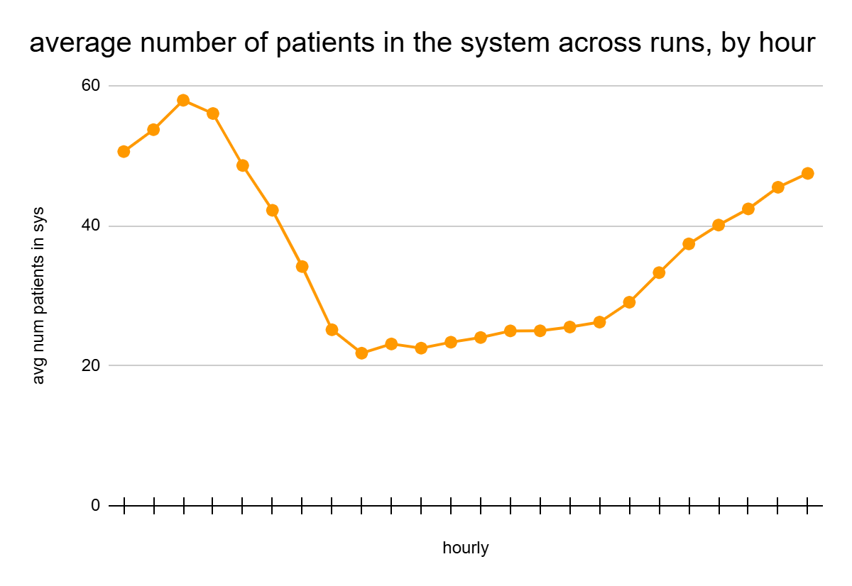Figure 2. Average number of patients in the system across runs, by hour.
Avg wait time across runs, by hour
 | Hour
Run # | 0 | 1 | 2 | 3 | 4 | 5 | 6 | 7 | 8 | 9 | 10 | 11
1 | 334.10 | 353.55 | 362.89 | 346.72 | 219.78 | 187.78 | 148.84 | 78.44 | 99.88 | 137.21 | 114.73 | 152.33
2 | 235.42 | 244.95 | 264.70 | 284.11 | 147.55 | 111.86 | 71.52 | 107.05 | 109.23 | 147.55 | 108.70 | 155.70
3 | 299.87 | 305.20 | 321.24 | 295.83 | 314.05 | 159.22 | 163.48 | 72.12 | 114.40 | 124.34 | 101.25 | 112.38
4 | 316.38 | 328.37 | 347.44 | 257.70 | 260.12 | 121.39 | 152.97 | 94.18 | 144.49 | 125.85 | 131.43 | 136.35
5 | 312.81 | 335.99 | 342.92 | 301.81 | 245.24 | 172.63 | 203.59 | 75.46 | 67.41 | 103.21 | 115.96 | 129.21
6 | 271.94 | 305.63 | 317.34 | 264.76 | 215.64 | 135.45 | 161.05 | 102.96 | 138.00 | 108.01 | 134.10 | 132.42
avg | 295.09 | 312.28 | 326.09 | 291.82 | 233.73 | 148.05 | 150.24 | 88.37 | 112.23 | 124.36 | 117.70 | 136.40
stdev | 35.80 | 37.82 | 34.53 | 31.89 | 55.19 | 29.96 | 43.23 | 15.00 | 27.86 | 16.85 | 12.81 | 35.80
CI | [257.52, 332.66] | [272.59, 351.97] | [289.85, 362.33] | [258.35, 325.30] | [175.81, 291.65] | [116.61, 179.49] | [104.87, 195.61] | [72.63, 104.11] | [83.00, 141.46] | [106.68, 142.04] | [104.25, 131.15] | [119.67, 153.13]
 | Hour
Run # | 12 | 13 | 14 | 15 | 16 | 17 | 18 | 19 | 20 | 21 | 22 | 23
1 | 149.64 | 126.01 | 147.75 | 116 | 146.74 | 153.43 | 190.42 | 247.24 | 274.39 | 305.39 | 321.33 | 335.72
2 | 107.7 | 129.41 | 110.79 | 99.727 | 119.44 | 169.74 | 197.53 | 225.87 | 212.47 | 195.76 | 227.08 | 247.4
3 | 123.09 | 106.88 | 106.05 | 130.31 | 146.16 | 165.55 | 212.84 | 220.23 | 236.51 | 253.53 | 254.82 | 292.5
4 | 112.32 | 117.2 | 115.02 | 143.72 | 132.63 | 175.08 | 212.51 | 195.25 | 250.37 | 281.64 | 259.23 | 289.62
5 | 112.09 | 127.4 | 124.76 | 123.32 | 140.33 | 133.12 | 194.31 | 181.4 | 238.93 | 278.42 | 264.66 | 270.86
6 | 126.68 | 120.73 | 117.17 | 109.44 | 133.14 | 128.42 | 177.69 | 214.62 | 226.83 | 265.99 | 244.47 | 284.95
avg | 121.92 | 121.27 | 120.26 | 120.42 | 136.41 | 154.22 | 197.55 | 214.1 | 239.92 | 263.45 | 261.93 | 286.84
stdev | 15.38 | 8.37 | 14.86 | 15.60 | 10.30 | 19.58 | 13.52 | 23.23 | 21.14 | 37.42 | 32.00 | 29.13
CI | [105.77, 138.06] | [112.49, 130.06] | [104.67, 135.86] | [104.05, 136.79] | [125.60, 147.77] | [133.68, 174.77] | [183.37, 211.74] | [189.72, 238.49] | [217.73, 262.11] | [224.19, 302.72] | [228.37, 295.49] | [205.56, 218.92]
Table 13. Average wait times across runs, by hour, where hour 0 is 00:00 on a 24-hour clock.
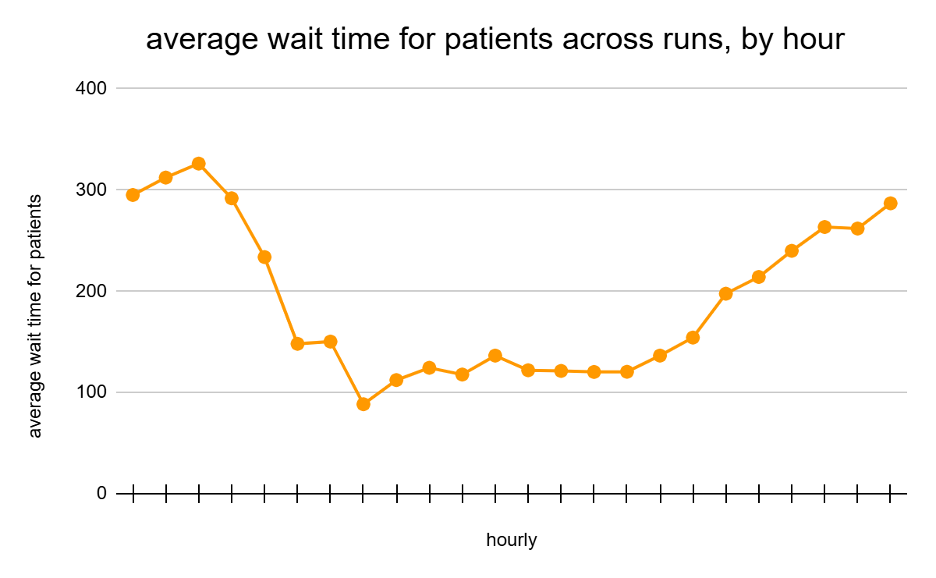
Figure 3. Average wait time for patients in the system across runs, by hour.
Averages across runs by day
day | total patients complete | avg time in sys | standard deviation of time in sys (min)
4 | 274.50 | 207.21 | 208.82
5 | 246.33 | 175.05 | 203.60
6 | 244.00 | 179.67 | 208.50
7 | 260.00 | 187.02 | 208.76
8 | 275.17 | 200.34 | 216.11
9 | 258.67 | 189.40 | 211.16
10 | 259.00 | 188.32 | 206.96
11 | 272.33 | 188.95 | 211.45
12 | 245.83 | 194.93 | 211.95
13 | 257.17 | 217.84 | 229.16
14 | 262.67 | 199.15 | 207.95
15 | 264.67 | 196.70 | 220.91
16 | 269.50 | 193.57 | 208.40
17 | 267.83 | 183.60 | 215.24
18 | 274.00 | 206.26 | 214.66
Avg | 262.11 | 193.87 | 212.24
Stdev | 10.54 | 11.24 | 6.36
CI | [251.05, 273.18] | [182.07, 205.66] | [205.56, 218.92]
Table 14. Averages across runs, by day.
Here are a few key observations of this data:
- The confidence intervals of the total patients helped in the system and the average time patients spent in the ER each day were relatively narrow. This shows the ED does not accumulate a backlog from previous days, which supports the validity and stability of the simulation.
- The smallest average number of patients in the system occurred during Hour 8. The confidence interval does not overlap with the Hour 2, when the system has the largest average number of patients in the system, which suggests that there will always be less patients in the ED in the morning than at night.
- The smallest average wait time occurred for patients who arrived during Hour 7 (7:00–7:59 a.m.). The confidence interval of Hour 7 wait times do not overlap with the confidence interval of hours with the highest wait times. This indicates that there is a meaningful difference between the high-wait and low-wait times.
- Hours 6, 7, and 8 have comparatively lower wait times and number of customers in the system than other periods of time, and their confidence intervals overlap with each other but not with the highest wait times. This means that there is a stable arrival window between 6:00–8:59 a.m. where patients will consistently face low congestion.
  - Furthermore, the lowest standard deviations among all hours occurred between Hours 7–8 and their confidence intervals are relatively narrow and overlap heavily. This means the system is most predictable during these hours, so patients can reliably expect to have relatively fast wait times if they arrive between 7:00–8:59 a.m.
- The smallest average wait times, largest standard deviations, and widest confidence intervals occurred between Hours 0–3 and 20–23. Even the lower bounds of these time periods are substantially higher than those in the lowest-congestion periods. This indicates that patients arriving between 8:00 p.m.–3:59 a.m. experience the slowest departures from the system and can always expect longer wait times than if they had arrived at other periods during the day.
  - The hours with the highest average wait times also match the hours with the most patients in the system, suggesting that the high wait times during these periods are a direct result of the increased congestion in the system.

Conclusion

Results and Analysis Summary: Theoretical
The theoretical system data shows that the queues, with the exception of diagnosis queue, maintain low and stable patient numbers and wait times, with mid-day peaks due to higher patient arrivals. Utilization is low, indicating the system can handle the typical, expected flow and to indicate that while there are periods of extended waits for patients, those times will always be caught up when high staffing periods occur. Observation queue numbers are high but predictable, while the diagnosis queue shows instability when arrivals exceed doctor staffing, causing extreme queue lengths and wait times. Later staffing increases allow recovery, demonstrating that capacity constraints drive temporary backlogs, but stability is achievable over time.

Results and Analysis Summary: Simulation
The actual simulation results indicate the ED is completely stable over many days, and generally stable with through each day with narrow confidence intervals, which show minimal backlogging of patients. Congestion is lowest between 6:00–8:59 a.m., with predictable short wait times, while highest congestion occurs between 8:00 p.m. and 3:59 a.m., with long waits and many patients. These showcase how the system struggles with low staffing times but maintains consistent and reliable service during high staff times. Differences between low- and high-congestion periods are meaningful, confirming that patient experience varies by hour, and highlighting consistent morning stability versus persistent nighttime demand.
Based on the results from the simulation, there is a clear standout time for patients to enter the system to minimize their overall wait time: 07:00–07:59. Patients who entered the system after 07:00 and before 08:00, on a 24-hour clock, had a significantly reduced wait time compared to every other hourly interval. The longest wait patients experienced on average were patients who entered the system between 8:00 p.m.–3:59 a.m.

Recommendations
In terms of the simulation code, there are a few edge cases that the system does not handle well, such as when two patients arrive at the same time. To avoid this, currently the code to arrive in the testing and diagnosis queues is called directly after leaving the previous queue, rather than scheduling the arrival. This is improper and occasionally dangerous system behaviour that could potentially cause statistical problems if patient volumes were increased, so a system to handle simulatneous arrivals should be implemented in future iterations of the project. Another way to improve the simulation code could be to track the system time on a counter, rather than increasing the time with each event. This would allow for more accurate statistic tracking as it would stop the simulation at the exact end of day, preventing the system from overshooting it (e.g. the last event of the simulation occurs at 11:59 p.m. and takes two minutes, so the system actually ends at 12:01 a.m.).
The statistical data for this simulation could be improved by testing the system with different patient arrival rates to see how the recommended hours for ED arrival change. It would also be interesting to track queue congestion statistics, such as the average number of patients in each queue or their delay, or the nurse and doctor serving data to help identify points of congestion and allow patients to choose arrival times that have shorter waits in specific queues, rather than overall system time. Many assumptions were made about the efficiency of an actual ED that should be addressed if the goal was to improve the accuracy of the simulation. For example, future work on this project could add a chance for patients with lower priorities to leave without being seen while in triage and testing queues, add a separate PES queue to handle patients brought in against their desires, or include shift changes for doctors monitoring the waiting queue. Modifications to this simulation could also be made to analyze optimal staffing levels of each queue to assist hospitals with managing congestion.

References
Anon (2004) Patient crowding in hospital emergency rooms just keeps getting worse: union. Toronto: Canadian Press Enterprises Inc.
Chan, C. (2025) Wait time at Great Victoria hospital ERs among longest in B.C.: report. Vancouver Sun and Times Colonist.
Zeidler, M. (2025) Island Health launches estimated ER wait times website: Langford mom who started Facebook group to crowd-source wait times says new website is welcome. Toronto: Canadian Broadcasting Corporation.

Table of Figures
Figure 1. Shows the simulation flow for patients from triage through to discharge.
Figure 2. Average number of patients in the system across runs, by hour.
Figure 3. Average wait time for patients in the system across runs, by hour.

Table of Tables
Table 1. Average service time per nurse at each queue, tracked hourly.
Table 2. Arrival rates of patients to triage, tracked in time intervals.
Table 3. Staffing levels at triage, tracked in time intervals.
Table 4. Staffing levels at the testing, tracked in time intervals.
Table 5. Staffing levels at diagnosis, tracked in time intervals.
Table 6. Theoretical data for triage queue.
Table 7. Theoretical data for Xray queue.
Table 8. Theoretical data for ECG queue.
Table 9. Theoretical data for Bloodwork queue.
Table 10. Theoretical data for diagnosis queue.
Table 11. Theoretical data for the observation queue.
Table 12. Number of patients in system across runs, by hour.
Table 13. Average wait times across runs, by hour, where hour 0 is 00:00 on a 24-hour clock.
Table 14. Averages across runs, by day.

